Cybersecurity Analyst Internship
Task Report

[samfelix15@gmail.com]
Task No: [ 5 - Password Cracking Basics]

Copyright © 2024 EncryptEdge Labs. All rights reserved
Credit: Offensive Security

Table of Contents
1.0 EncryptEdge Labs Internship Task Report 1
1.1 Introduction 2
1.2 Objective 3
1.3 Requirements 5
2.0 High-Level Summary 5
2.1 Recommendations 11
2.2 Risk exposure over time 12
3.0 Report - Methodologies 13
3.1 Challenges 13
4.0 Additionals Item
4.1 Screenshots 14
1.0 EncryptEdge Labs Internship Task Report
1.1 Introduction
Password cracking is a critical aspect of cybersecurity that involves identifying and exploiting weaknesses in password-based security systems. As the digital landscape continues to evolve, password cracking has become an essential tool for both attackers and defenders. In this report, we will delve into the basics of password cracking, exploring the techniques, tools, and methodologies used by attackers to compromise password-protected systems.
Password cracking is a complex and multifaceted field that requires a deep understanding of cryptography, computer systems, and human behavior. At its core, password cracking involves attempting to guess or calculate the correct password for a given account or system. This can be achieved through various means, including brute force attacks, dictionary attacks, and social engineering.
The importance of password cracking cannot be overstated. As the number of password-protected systems and accounts continues to grow, the potential attack surface expands exponentially. Attackers can use password cracking techniques to gain unauthorized access to sensitive data, disrupt critical infrastructure, and compromise national security.
Conversely, defenders or cybersecurity personnel can use password cracking techniques to test the strength of their own password policies, identify vulnerabilities, and improve overall security posture. By understanding how attackers operate, defenders can develop more effective countermeasures and stay one step ahead of emerging threats.

1.2 Objective
This report will provide a basic examination of password cracking basics, including:
1. Password cracking techniques : We will explore the various techniques used by test security defense to crack passwords, including brute force attacks and dictionary attacks
2. Password cracking tools: We will discuss the tools and software used to crack passwords, including John the Ripper, HYDRA. Other tools include Hashcat and Aircrack
3. Password security best practice: We will provide guidance on how to create strong, unique passwords and implement effective password policies to prevent password cracking attacks.
By the end of this report, readers will have a comprehensive understanding of password cracking basics and the importance of password security in the digital age. ‎

1.3 Requirements
This report will provide a summary explaining bruteforce and dictionary attacks and their use within ethical boundaries of cybersecurity analysis. Areas of significance also include,
1. Password cracking techniques: We will explore the various techniques used by attackers to crack passwords, including brute force attacks, dictionary attacks, and rainbow table attacks.
2. Password cracking tools: We will discuss the tools and software used by attackers to crack passwords, including John the Ripper, Aircrack-ng, and Hashcat.
3. Password security best practices: We will provide guidance on how to create strong, unique passwords and implement effective password policies to prevent password cracking attacks.
4. Real-world examples: We will examine real-world examples of password cracking attacks and discuss the consequences of these attacks.
By the end of this report, readers will have a comprehensive understanding of password cracking basics and the importance of password security in the digital age. ‎

What are Brute Force and Dictionary Attacks?
Brute force and dictionary attacks are types of password cracking techniques used to gain unauthorized access to a system, network, or application.
Brute Force Attack:
A brute force attack involves systematically trying all possible combinations of characters, numbers, and symbols to guess a password. This type of attack uses a trial-and-error approach, where the attacker tries a large number of password combinations until the correct one is found.
Brute force attacks can be performed using specialized software or hardware, such as graphics processing units (GPUs) or application-specific integrated circuits (ASICs). These tools can rapidly try millions of password combinations, making brute force attacks a significant threat to password-based security systems.
Dictionary Attack:
A dictionary attack is a type of password cracking technique that uses a list of words, phrases, and common passwords to guess a password. This type of attack is based on the idea that many users choose passwords that are easy to remember, such as words, names, or common phrases.
Dictionary attacks can be performed using a list of words, known as a dictionary, which is used to try different password combinations. This type of attack is often used in combination with other password cracking techniques, such as brute force attacks.
Use of Brute Force and Dictionary Attacks within Ethical Boundaries:
Brute force and dictionary attacks can be used within ethical boundaries for:
1. Penetration testing: Ethical hackers may use brute force and dictionary attacks to test the strength of passwords and identify vulnerabilities in password-based security systems.
2. Password auditing: System administrators may use brute force and dictionary attacks to audit passwords and identify weak or compromised passwords.
3. Security research: Researchers may use brute force and dictionary attacks to study password security and develop new techniques for improving password security.
However, it's essential to note that brute force and dictionary attacks should only be performed with explicit permission from the system owner or administrator and within the bounds of applicable laws and regulations.
Significance of Brute Force and Dictionary Attacks:
Brute force and dictionary attacks are significant threats to password-based security systems because:
1. Password weakness: Many users choose weak passwords that can be easily guessed or cracked using brute force or dictionary attacks.
2. Increased computing power: Advances in computing power and specialized hardware have made it possible to perform brute force and dictionary attacks more quickly and efficiently.
3. Password reuse : Many users reuse passwords across multiple accounts, which makes it easier for attackers to gain access to multiple systems or applications.
Best Practices for Preventing Brute Force and Dictionary Attacks:
To prevent brute force and dictionary attacks, follow these best practices:
1. Use strong passwords: Choose passwords that are at least 12 characters long and include a mix of uppercase and lowercase letters, numbers, and special characters.
2. Implement password policies: Enforce strong password policies, such as password length, complexity, and expiration requirements.
3. Use multi-factor authentication: Require users to provide additional forms of verification, such as a code sent to their phone or a biometric scan.
4. Limit login attempts: Limit the number of login attempts a user can make within a certain time period.
5. Monitor for suspicious activity: Regularly monitor system logs and network traffic for signs of brute force or dictionary attacks.
By following these best practices and using brute force and dictionary attacks within ethical boundaries, you can help improve password security and prevent unauthorized access to your systems and applications.
Importance in Cybersecurity:
Brute force and dictionary attacks are significant threats to cybersecurity because:
1. Password weaknesses : Many users choose weak passwords that can be easily guessed or cracked using brute force or dictionary attacks.
2. Increased computing power: Advances in computing power and specialized hardware have made it possible to perform brute force and dictionary attacks more quickly and efficiently.
3. Password reuse: Many users reuse passwords across multiple accounts, which makes it easier for attackers to gain access to multiple systems or applications.
4. Lack of awareness: Many users are not aware of the risks associated with weak passwords and the importance of password security.
Impact of Brute Force and Dictionary Attacks:
The impact of brute force and dictionary attacks can be severe, including:
1. Data breaches: Unauthorized access to sensitive data, including personal identifiable information (PII), financial information, and confidential business data.
2. System compromise: Compromise of systems, networks, and applications, leading to downtime, data loss, and reputational damage.
3. Financial losses: Financial losses due to stolen data, intellectual property theft, and other malicious activities.
4. Reputational damage: Damage to an organization's reputation and brand, leading to loss of customer trust and business.
2.0 High-Level Summary
The report on Password Cracking Basics provides a comprehensive overview of the technical and non-technical aspects of password cracking. The report covers the fundamental concepts of password hashing, cracking techniques, and tools, as well as the importance of password security best practices.
Technical Aspects:
The report delves into the technical aspects of password cracking, including:
Password Hashing: The process of converting plaintext passwords into hashed values for secure storage.
- Cracking Techniques: Various methods used by attackers to crack passwords, including brute force attacks, dictionary attacks, and rainbow table attacks.
- Cracking Tools: Commonly used tools and software for password cracking, such as John the Ripper, Hydra , Aircrack-ng, and Hashcat.
Non-Technical Aspects:
The report also emphasizes the importance of non-technical aspects, including:
Clear Language: Using simple, easy-to-understand language to explain complex technical concepts.
Real-World Examples: Providing real-world examples of password cracking attacks and their consequences to illustrate the importance of password security.
Visual Aids: Incorporating diagrams, flowcharts, and images to help explain technical concepts and make the report more engaging.
Report Format:
The report follows a structured format, including:
Introduction: Introducing the topic of password cracking basics and providing an overview of the report's contents.
Technical Overview: Providing a technical overview of password cracking, including password hashing, cracking techniques, and tools.
Password Security Best Practices : Offering guidance on creating strong, unique passwords and implementing effective password policies.
Real-World Examples : Including real-world examples of password cracking attacks and their consequences.
Conclusion: Summarizing the key points and takeaways from the report.
References: Providing a list of credible sources used in the report.
Overall, the report provides a comprehensive and informative overview of password cracking basics, highlighting the importance of password security and best practices to prevent password cracking attacks.

2.1 Recommendations
1. Stay informed: Stay up-to-date with the latest threats and vulnerabilities, including brute force and dictionary attacks
.
2. Conduct regular security audits. Perform regular security audits and vulnerability assessments to identify potential weaknesses in password-based security systems.
3. Implement strong password policies: Enforce strong password policies, such as password length, complexity, and expiration requirements.
4. Use multi-factor authentication: Require users to provide additional forms of verification, such as a code sent to their phone or a biometric scan.

5. Monitor for suspicious activity: Regularly monitor system logs and network traffic for signs of brute force or dictionary attacks.
By following these recommendations, organizations can reduce the risk of brute force and dictionary attacks and protect sensitive data and systems.

2.2 Risk Exposure over Time
Password cracking risk exposure can be measured over time using various metrics. Here's a breakdown of the risk exposure over time:
Short-Term Risk Exposure (0-30 days):
1. Initial Compromise The initial compromise of a password-protected system or account.
2. Lateral Movement: The attacker's ability to move laterally within the compromised system or network.
3. Data Exfiltration: The unauthorized transfer of sensitive data from the compromised system or network.
Medium-Term Risk Exposure (30-90 days):
1. Established Foothold: The attacker's ability to establish a persistent foothold within the compromised system or network.
2. Escalation of Privileges: The attacker's ability to escalate privileges and gain access to sensitive areas of the compromised system or network.
3. Data Encryption: The attacker's ability to encrypt sensitive data, making it unavailable to authorized users.
Long-Term Risk Exposure (90+ days):
1. Persistent Threat: The attacker's ability to maintain a persistent presence within the compromised system or network.
2. Advanced Threats: The attacker's ability to deploy advanced threats, such as malware, ransomware, or spear phishing attacks.
3. Reputation Damage: The potential for long-term reputation damage due to the compromise of sensitive data or systems.

3.0 Methodologies
This report is based on
Literature Review: Review of existing documentation and resource on password cracking eg. Youtube videos provided by Encryptedgde Labs, John the ripper cheat sheets,hydra cheat sheets etc.
Expert Input: Consultation with my mentors and provided tools by encrypted edge labs
Practical Input: Hands on Lab experience by TryHackMe, Hydra,Bruteforce, Heroes,Enumeration of Bruteforce.

3.1 Challenges
Upon using burp suite, I couldn’t finish my task on hacking a login credential in my attack box using try TryHackMe. However I was able to follow through the steps, but during my point of interception, I was able to get the coding(algorithm) for the simulated login but I couldn’t finish my attack using Hydra tool.

4.0 Additional Items
In a nutshell, brute force and dictionary attacks are two common types of password cracking techniques used by attackers to gain unauthorized access to systems, networks, and applications. These attacks exploit weak passwords and vulnerabilities in password-based security systems, making them a significant threat to cybersecurity. So users are highly advised to use pass sentences instead of short passwords. A password is considered to include uppercase, lowercase and alphanumeric characters.
4.1 Screenshots
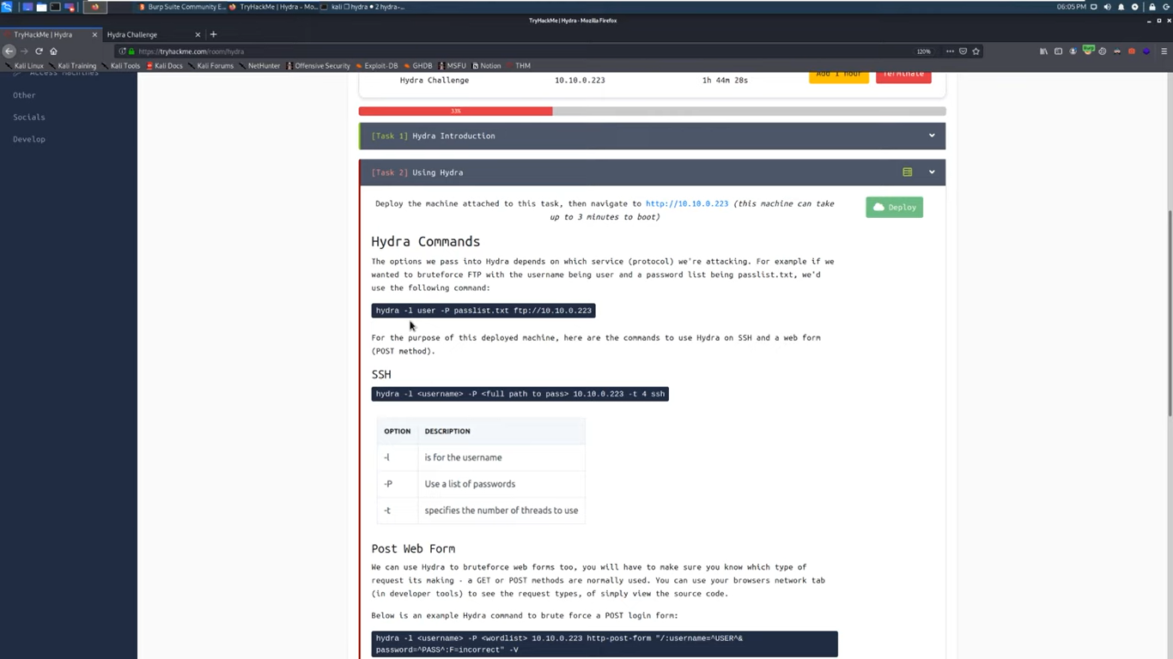
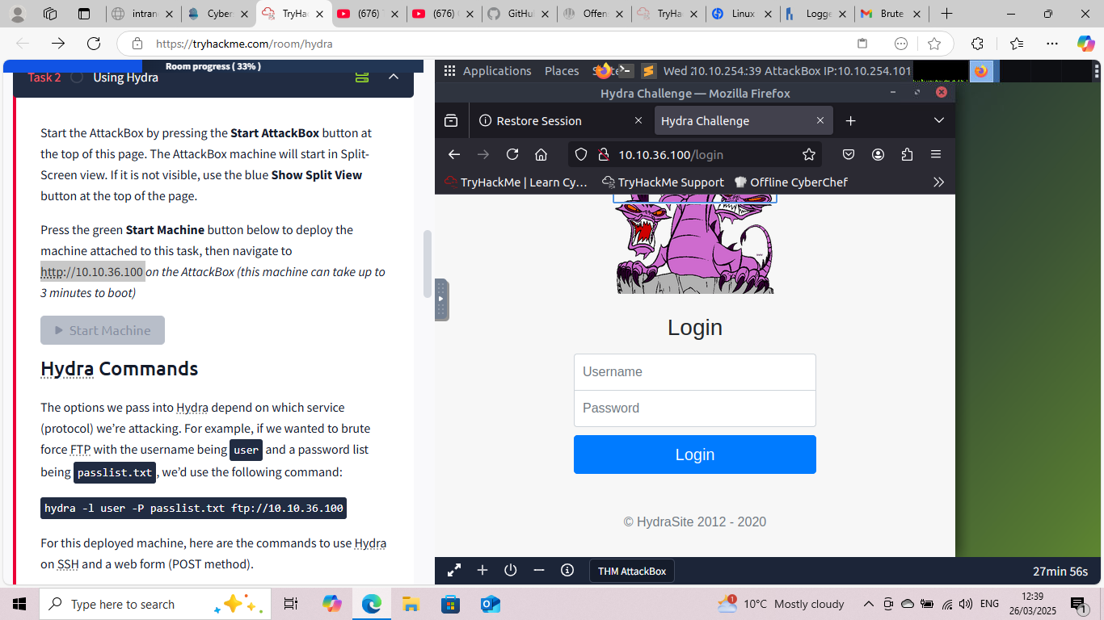
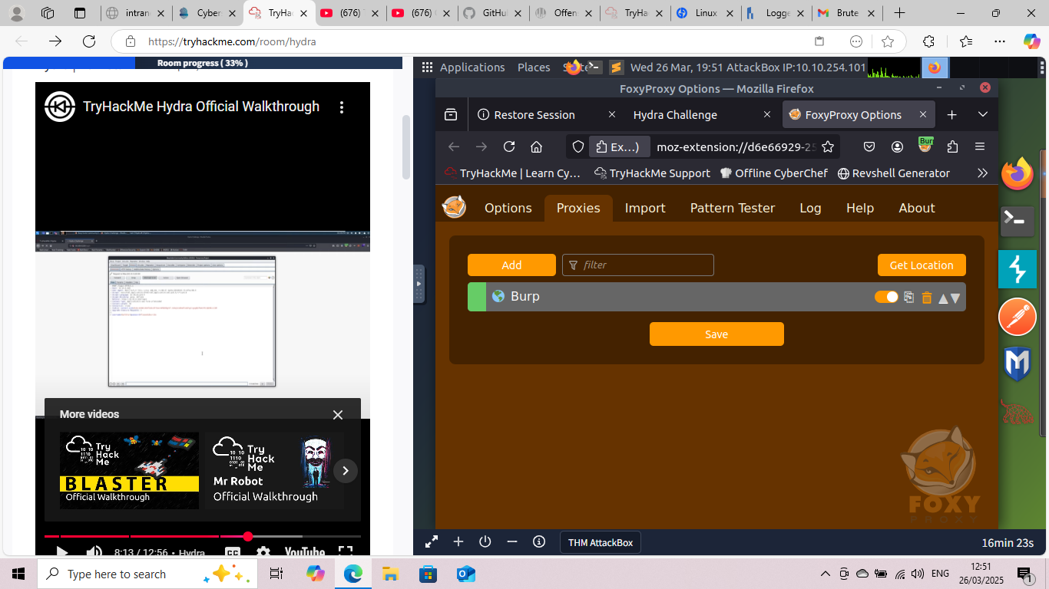
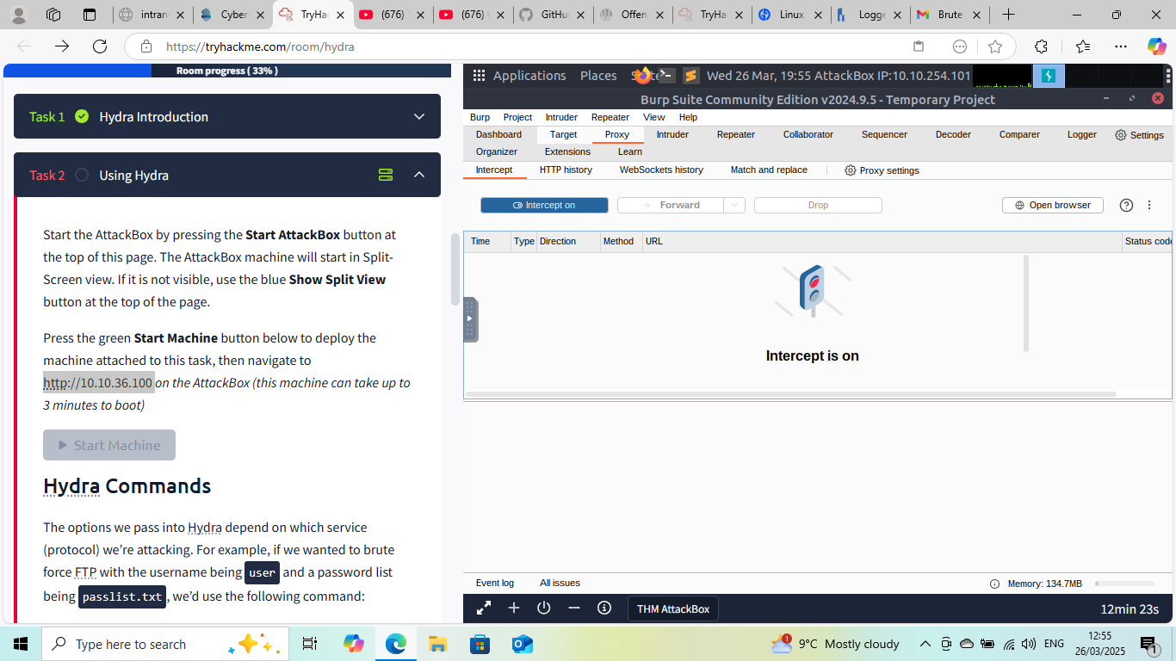
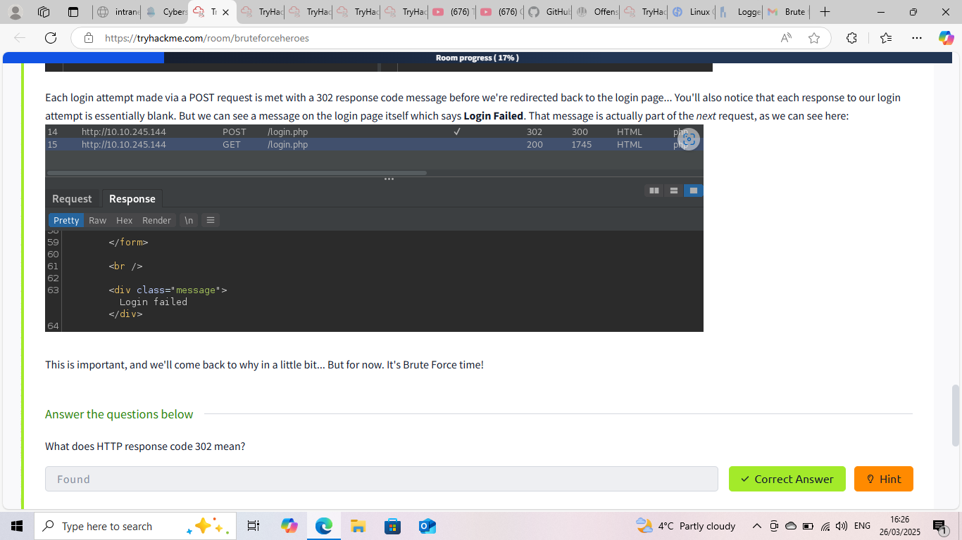
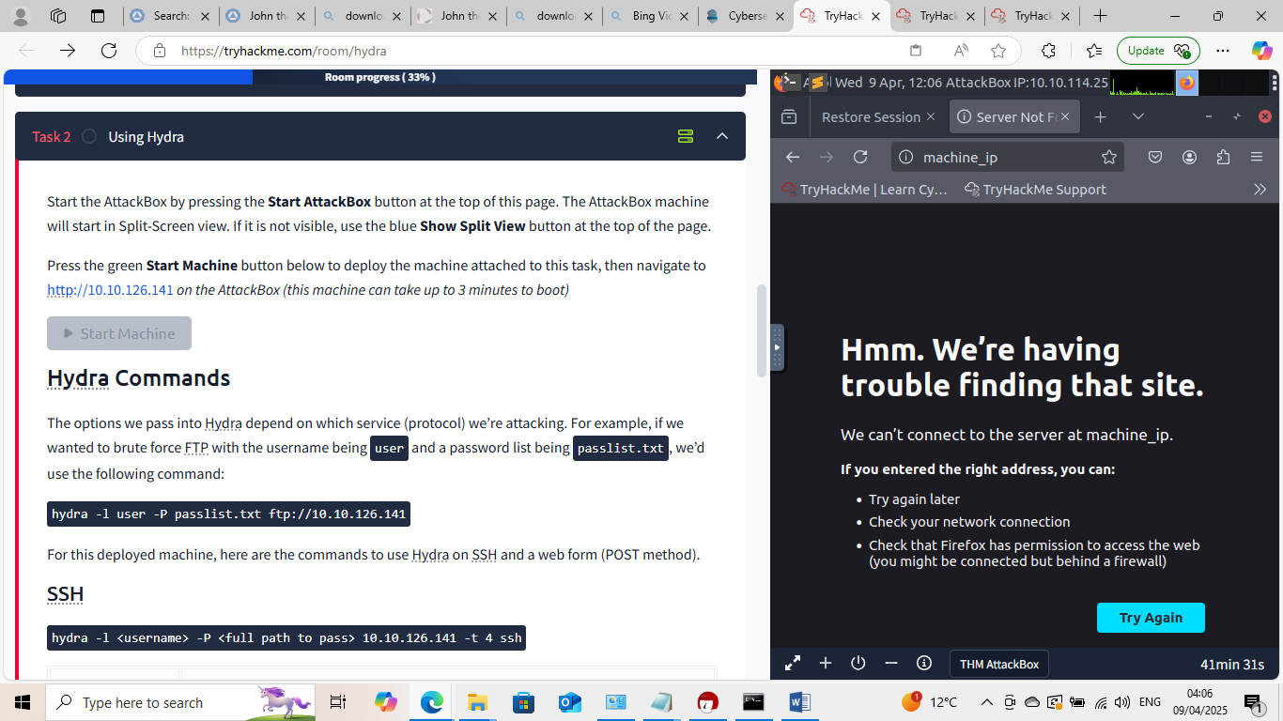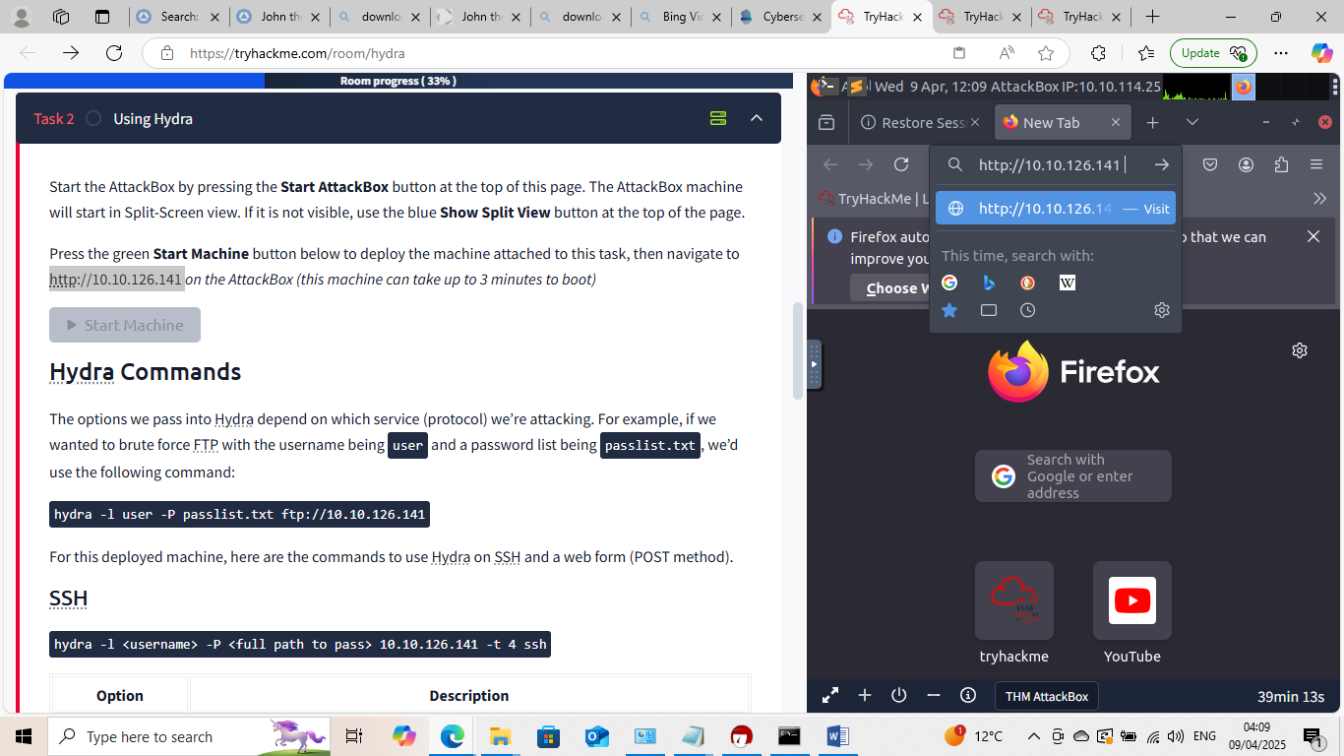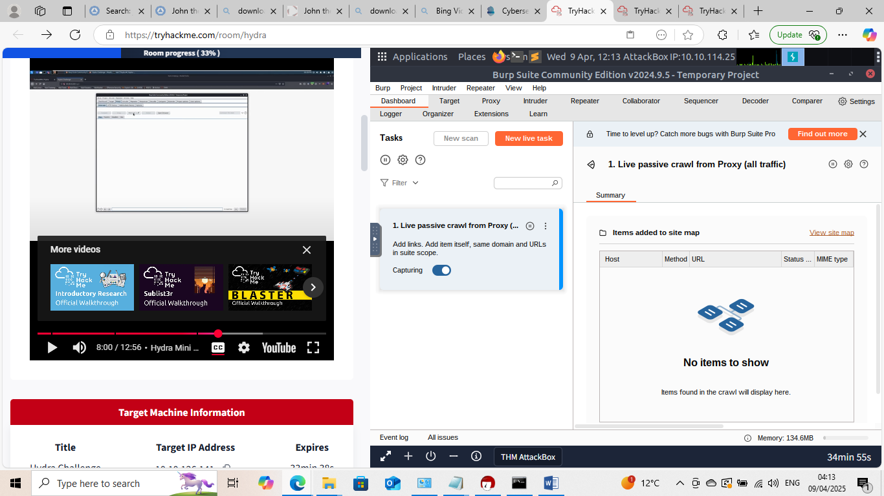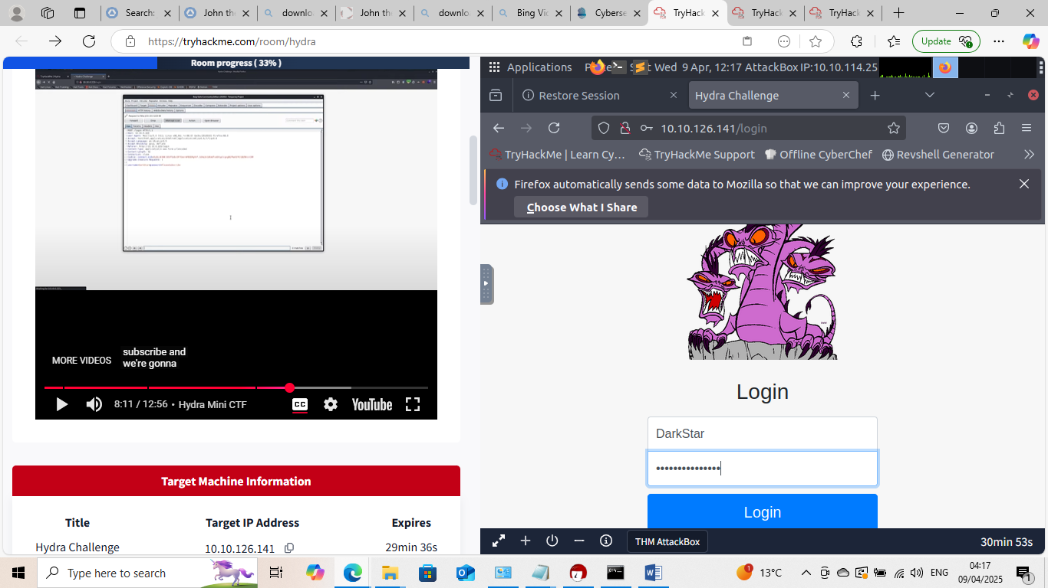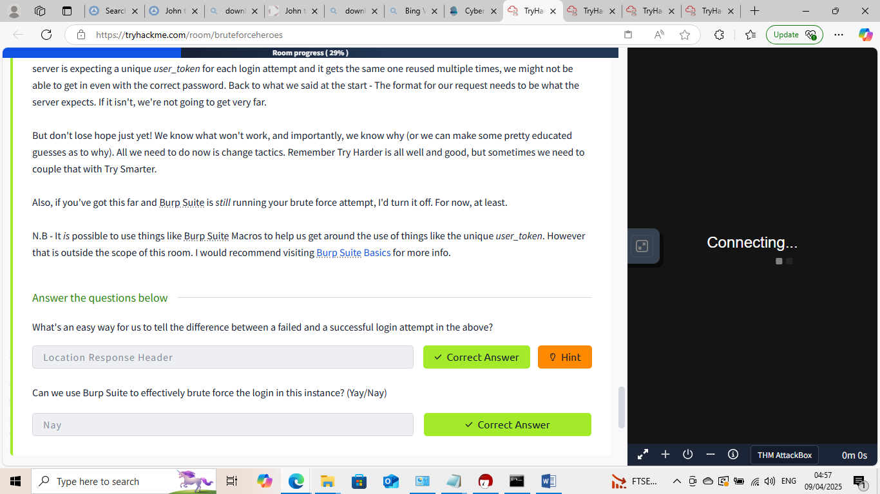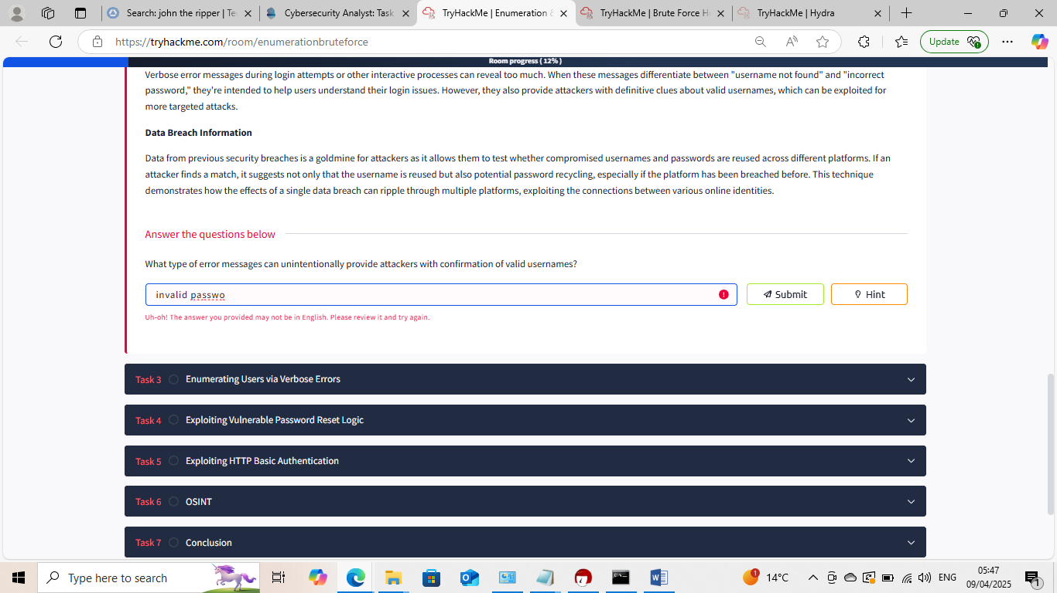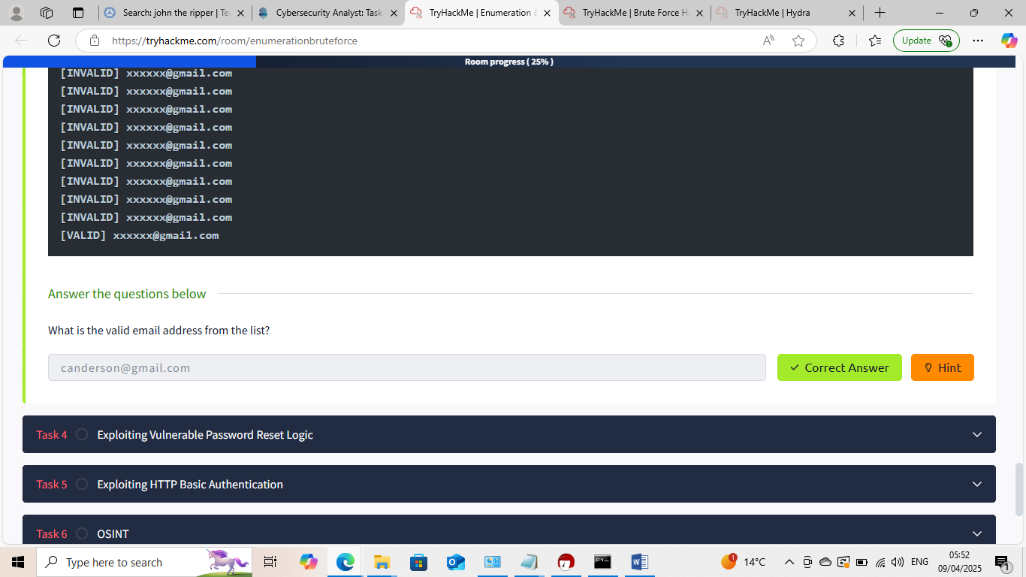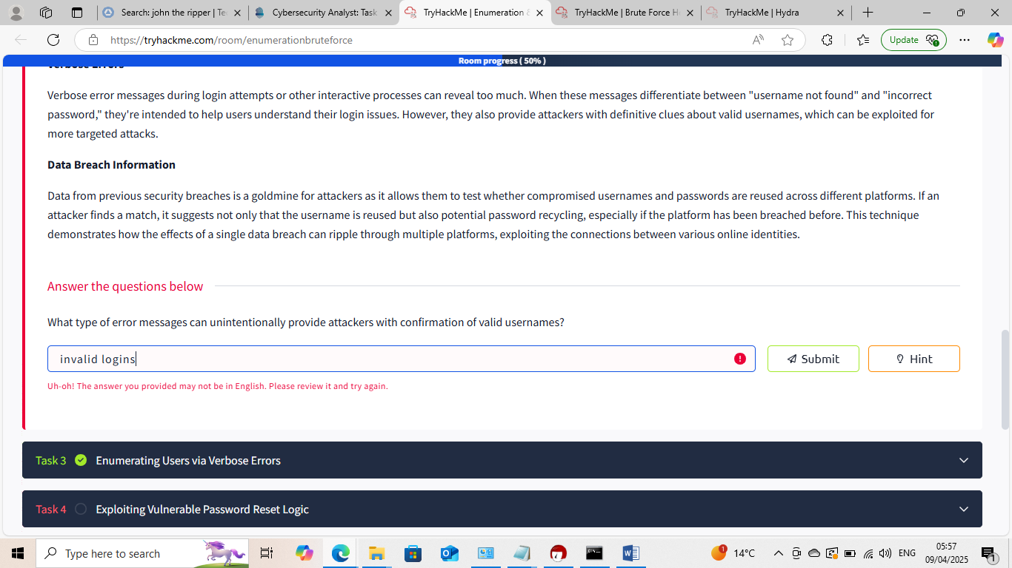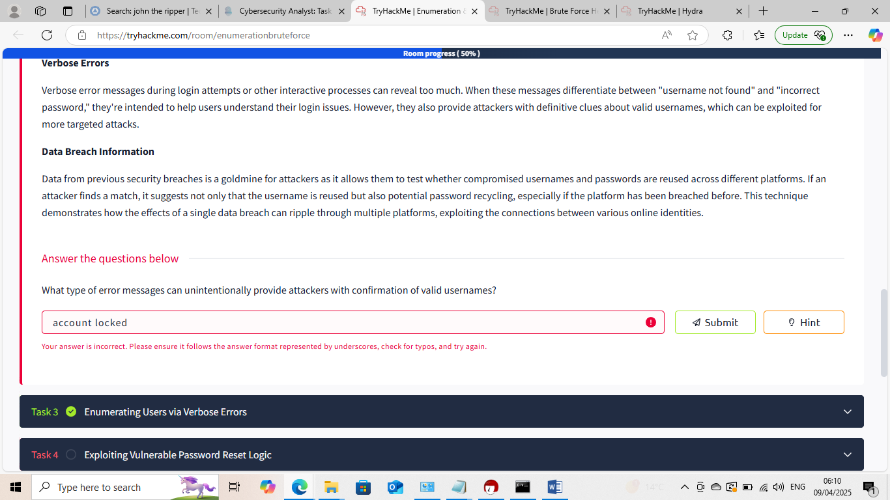

This Internship Task report was developed on [March,31,2025]

By:[samfelix15@gmail.com ]

